** **

**COMPUTER SCIENCE AND DATA ANALYTICS**

Course: Intro to Big Data Analytics

**Project 2**

Student(s):Emin Alizada, Rustam Talibzade

Instructor: **Dr. Abzatdin Adamov**

**Baku 2021**

Table of Contents

Part 1 3

Part 2 8

Part 3 11

Part 4 20

Discussion 26

# Part 1

We started exploration of our data model by pairs() function, pairs.panel() function and ggpairs() function to see the pairwise relationships between attributes and their correlation:

pairs() from standard packages:

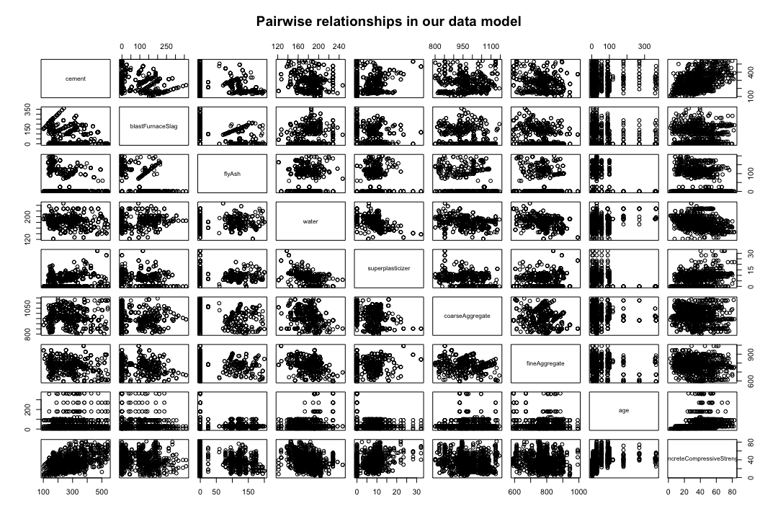

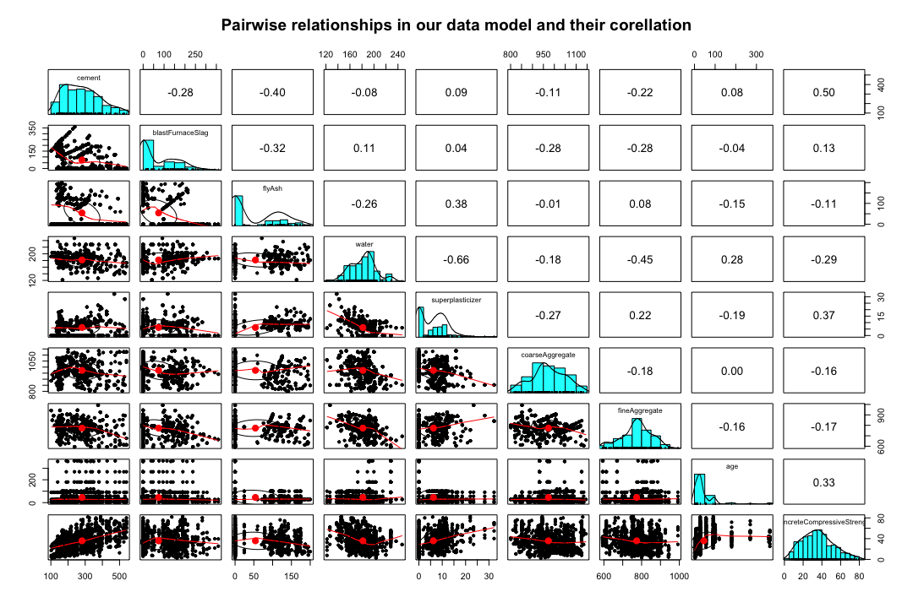pairs.panel() from psych package:

ggpairs() from GGally package:

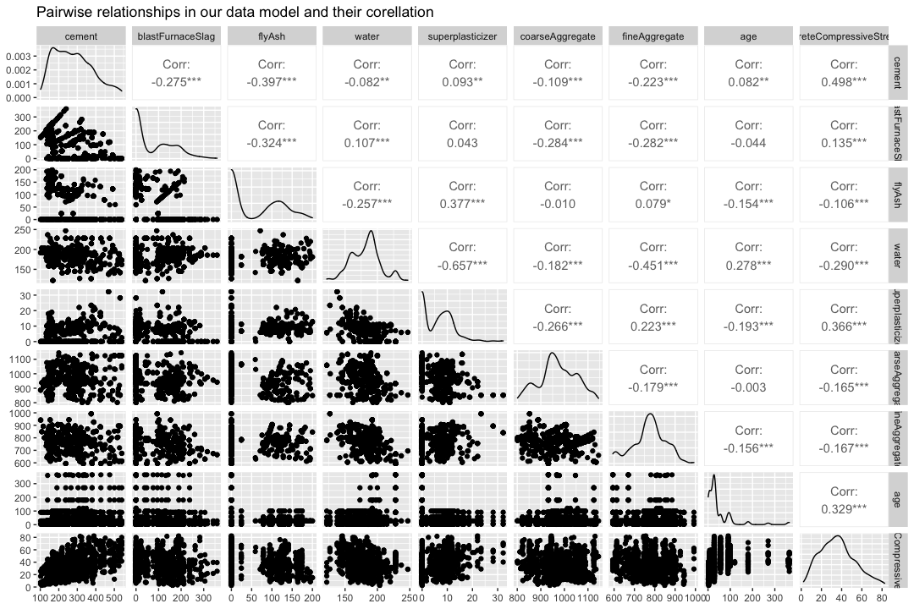

As can be seen from the plots additional packages provide extra functionality while paring attributes, they also show their correlation to each other.

From the produced outputs we can see the biggest correlation between the relationship of superplasticizer and water which is -0.657, it means they have negative trend, so increase in amount of water ends up in decrease in amount of superplasticizer.

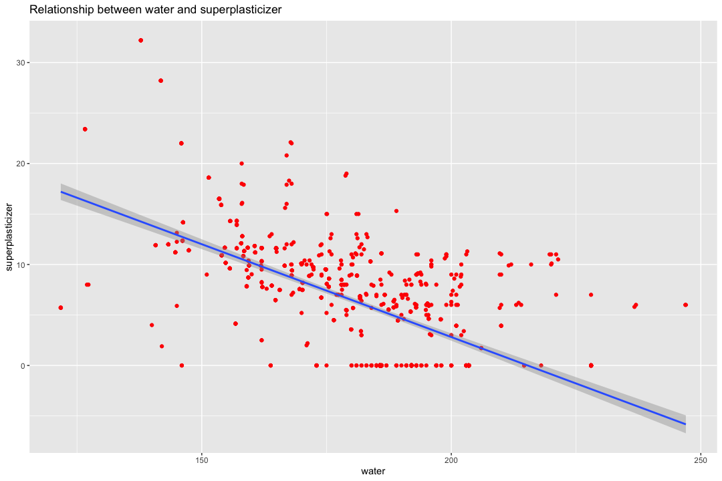

Second biggest correlation is observed between cement and concrete compressive strength which is 0.498, it means they have positive trend, so increase in amount of cement in mixture means increase in concrete compressive strength.

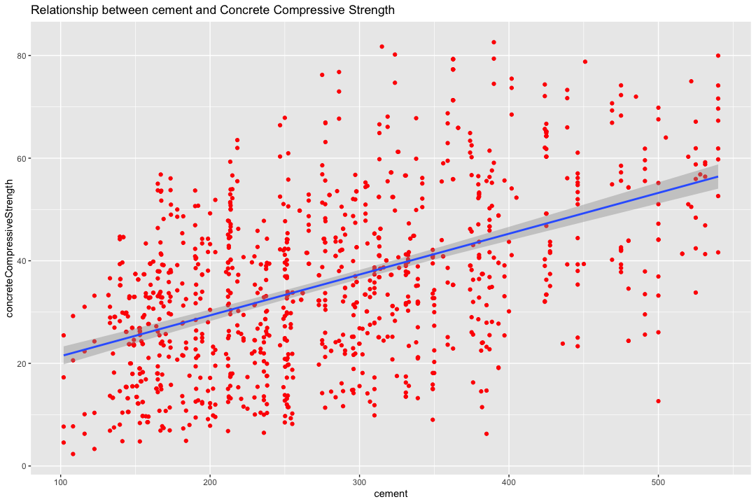

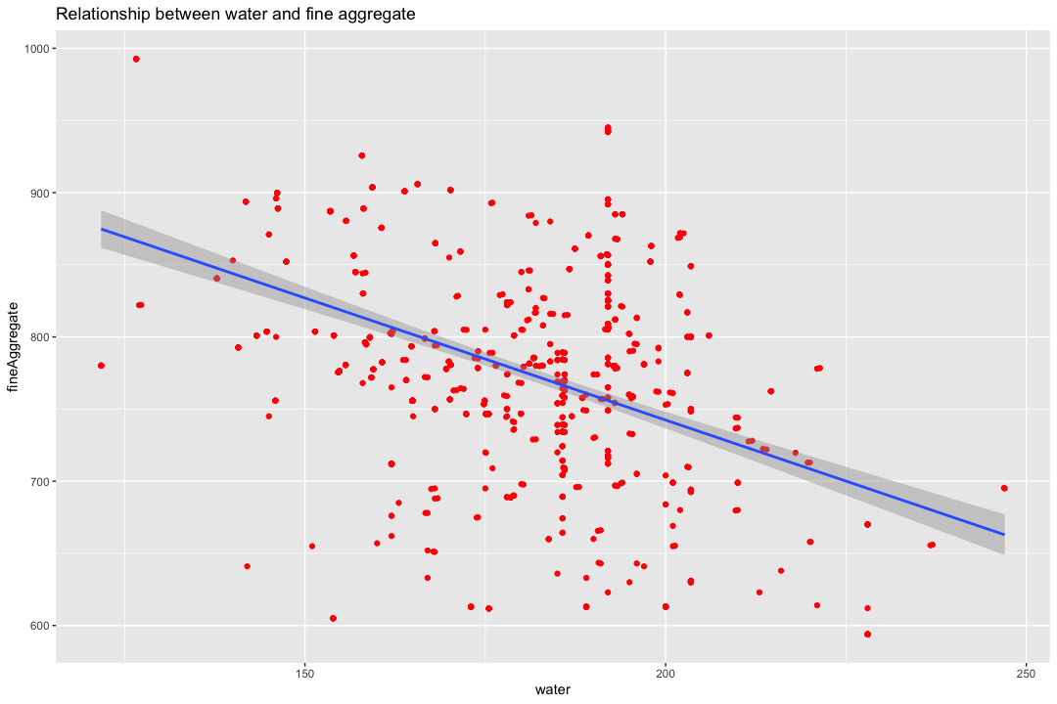Another interesting relationship is observed between water and fine aggregate, they have a correlation of -0.451. More water means less fine aggregate in the mixture.

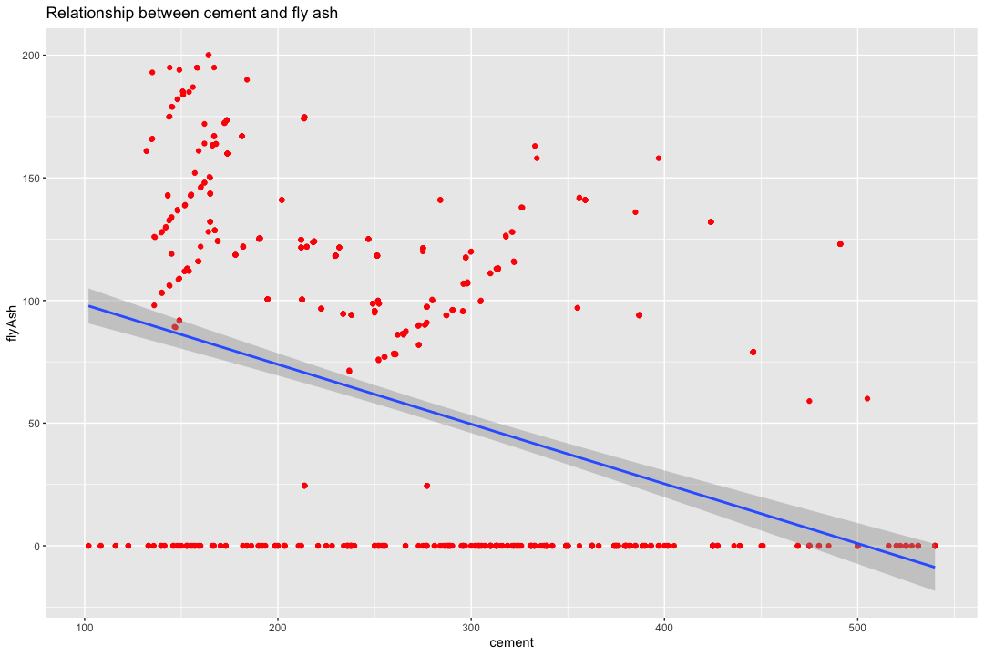Lastly, there is a high correlation between cement and fly ash, which is -0.397. Again there is a negative trend between them, so more cement usually means less fly ash.

# Part 2

The first function we have used is str() which shows us structure of an object in R. As can be seen, our data frame has 1030 observations of 9 variables and all variables are numbers.

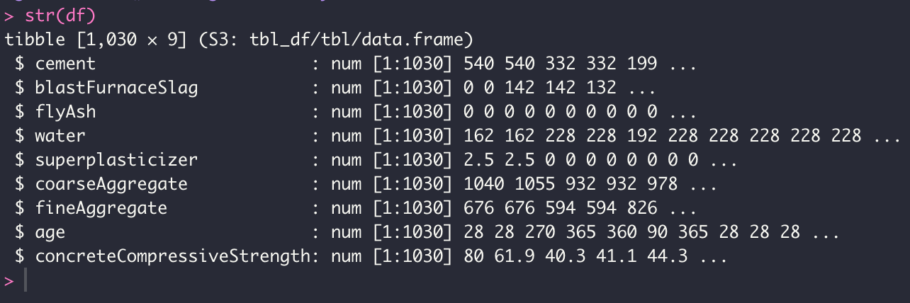

After that we looked at the summary of our data with summary() function. This function gives us minimum, maximum, mean , median values for each variable, and outputs if the column has NA value. In our case no column has NA values, so no need to apply na.omit function.

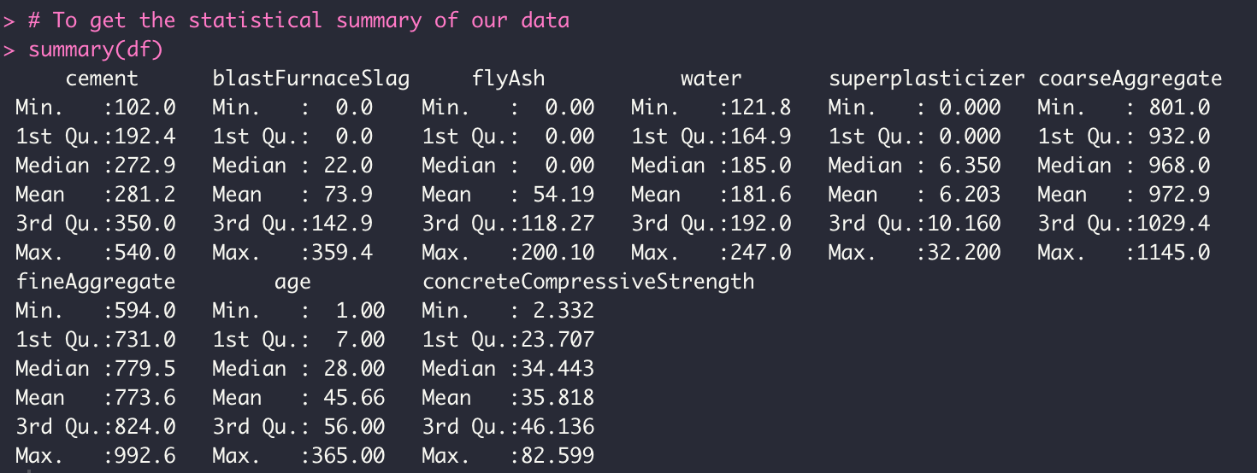

Another statistical summary by psych package’s describe() function. This function shows most values from summary function, but also adds another statistical properties as skew, standard deviation , kurtosis, etc.

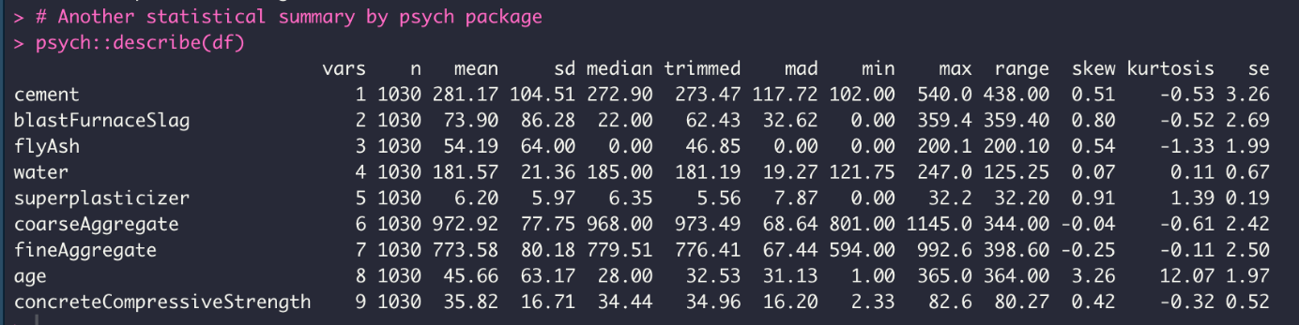

The next step is scaling of the data. The main purpose of scaling is to normalize so that larger values for certain variables don’t overwhelm the smaller values of other variables. There are two ways of normalization. The first is min-max normalization which linearly tranforms x to y with formula y = (x-min)/(max-min) where min and max are minimum and maximum values in that variable. The second way of normalization is called z-score normalization which tranforms input set into output set whose mean is almost 0 and standard deviation is close to 1. Let’s apply both normalization techniques to our data:

Before normalization:

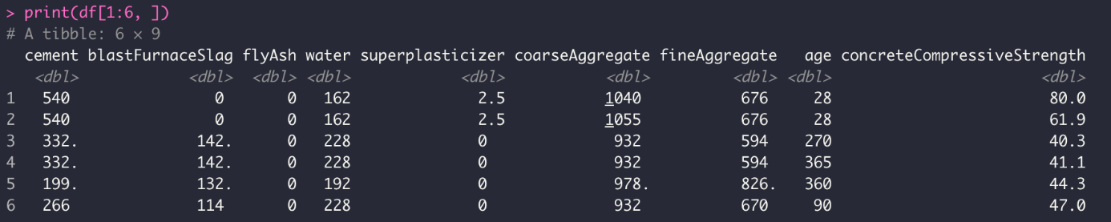

Min-max normalization:

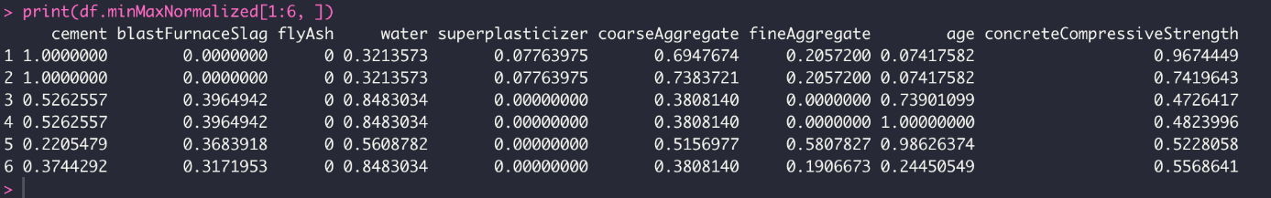

Z-score normalization:

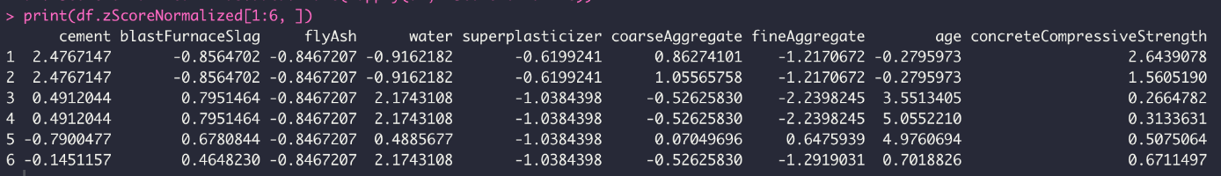

As the difference of these two normalization techniques, we see that z-score normalization contains negative values as well, while min-max contains values from 0 to 1.

To pick the most correlated attributes for the further analysis we decided to closely examine correlations in our dataset. With cor() function we got the correlation matrix of our attributes:

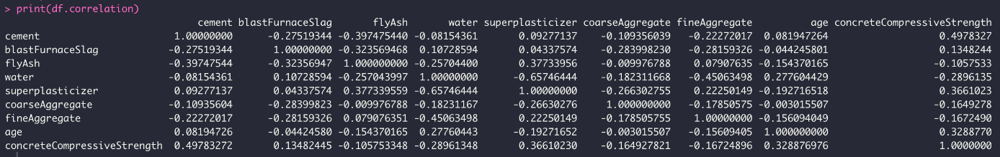

In order to better visualize it we used corrplot package’s corrplot() function:

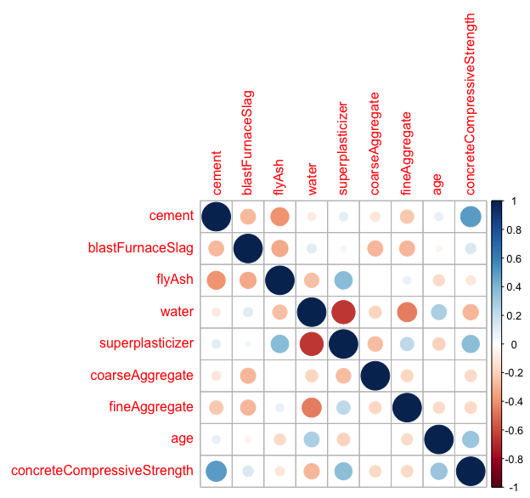

Looking at correlation matrix and plot, Blast Furnace Slag seems to be very little correlation with most of other attributes, therefore it can be removed. Another attribute that is not also so correlated with others is age, again it has very little correlation, so it will be removed to decrease dimensionality of analysis. Lastly, we decided to remove fly ash attribute because majority of the values of fly ash is 0, even the median of it is 0, we thought that it will negatively affect further analysis, therefore decided to remove it.

# Part 3

Application of K-means to our data.

With k = 2:

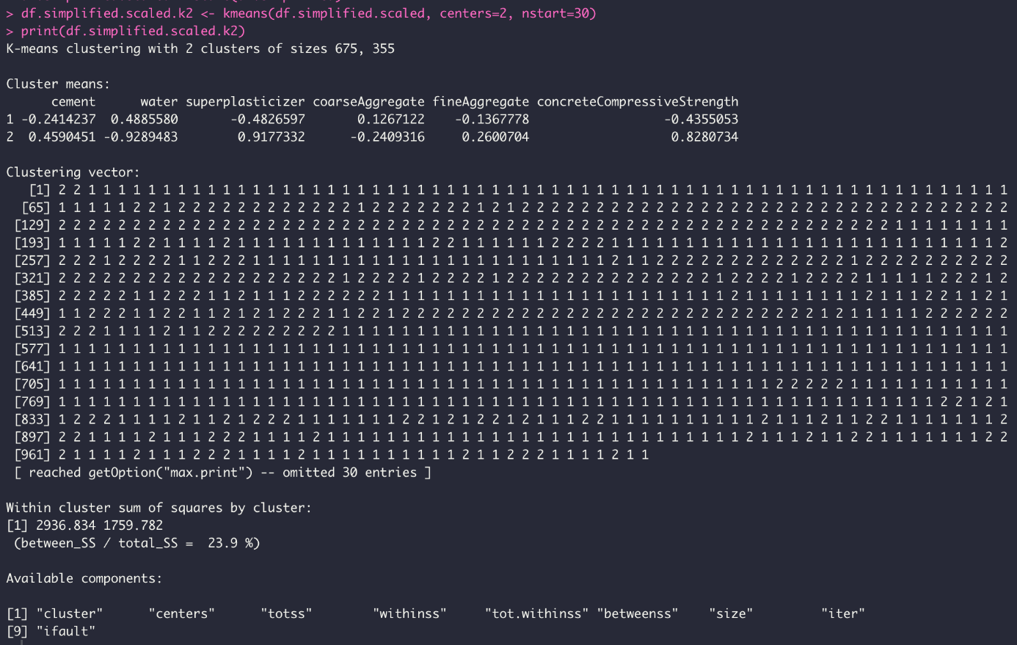

between_ss/total_ss = 23.9 %

The visualization of clusters:

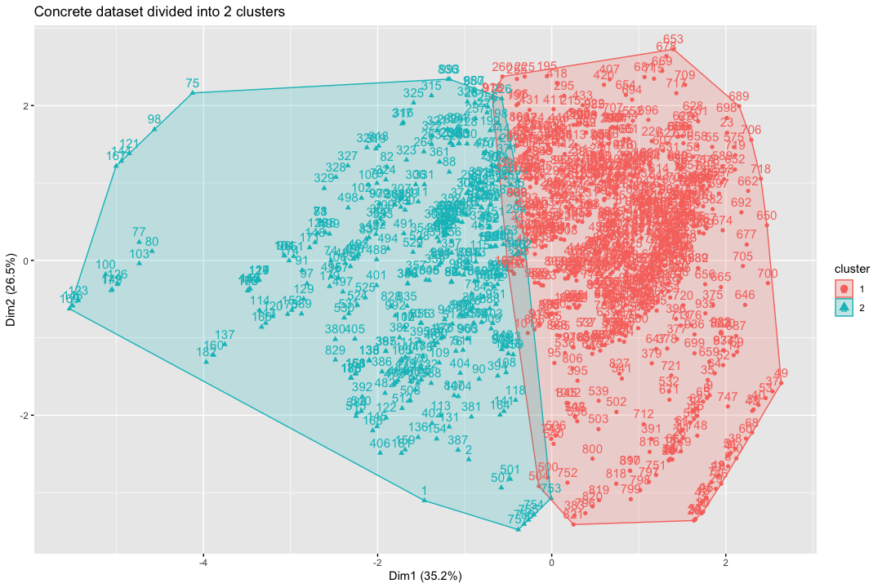

As we see two clusters are obviously separated with small overlapping area.

With k = 3:

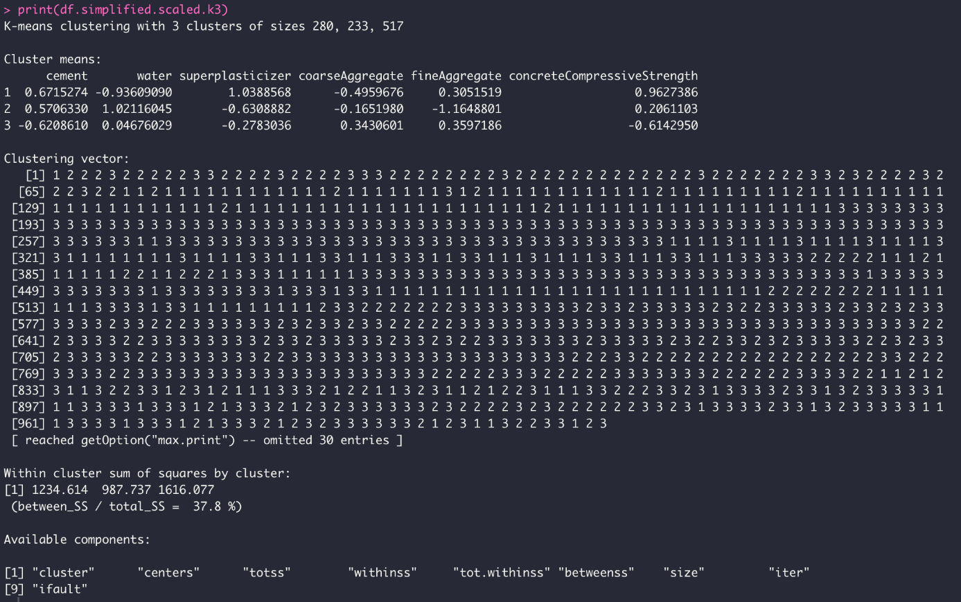

between_ss/total_ss has improved by about 14% to 37,8%.

The visualization of clusters:

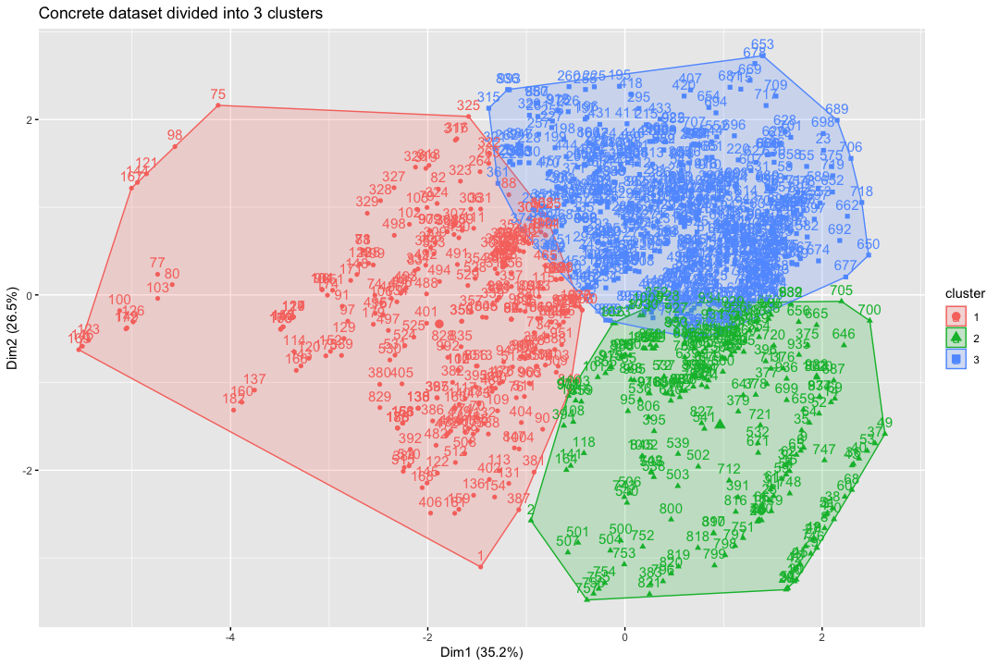

We can clearly observe three clusters on the visual, with some overlapping areas between red and blue clusters, as well as between blue and green clusters.

With k = 4:

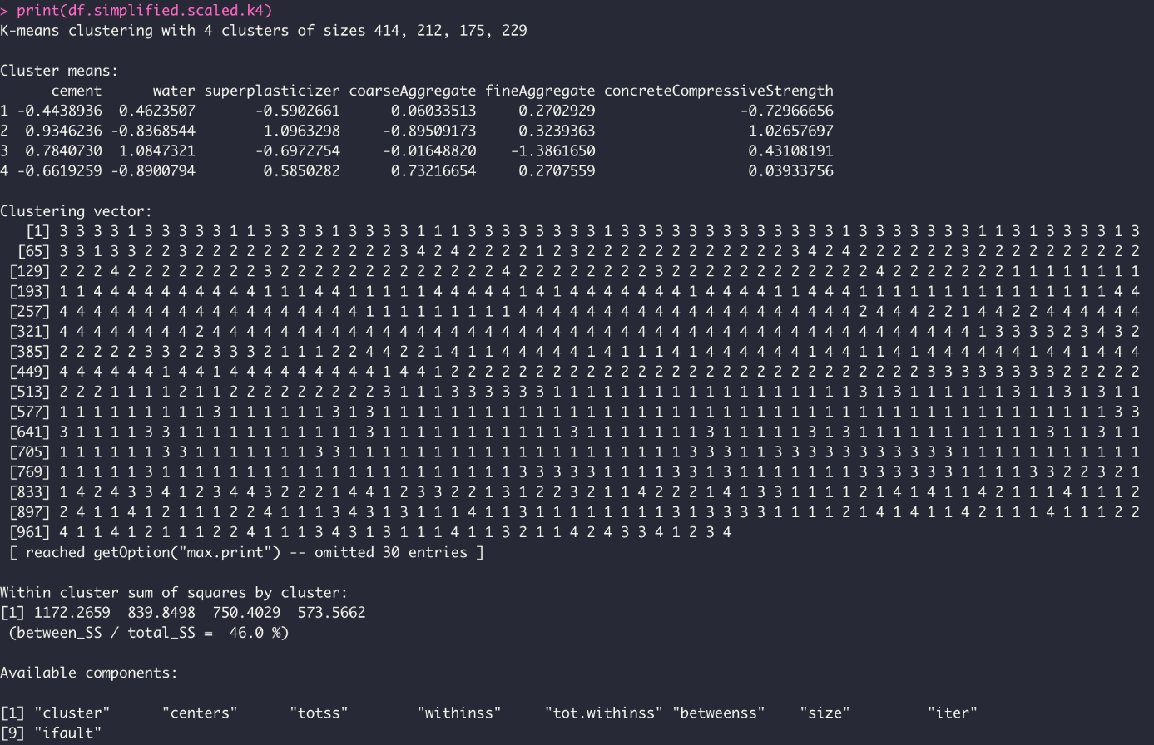

between_ss/total_ss has improved by about 8% to 46,0%.

The visualization of clusters:

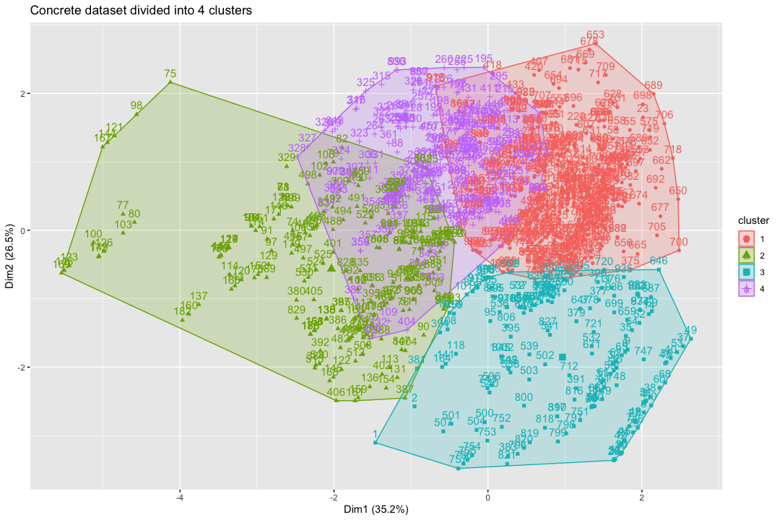

Now the overlapping area has significantly increased with purple cluster.

With k = 5:

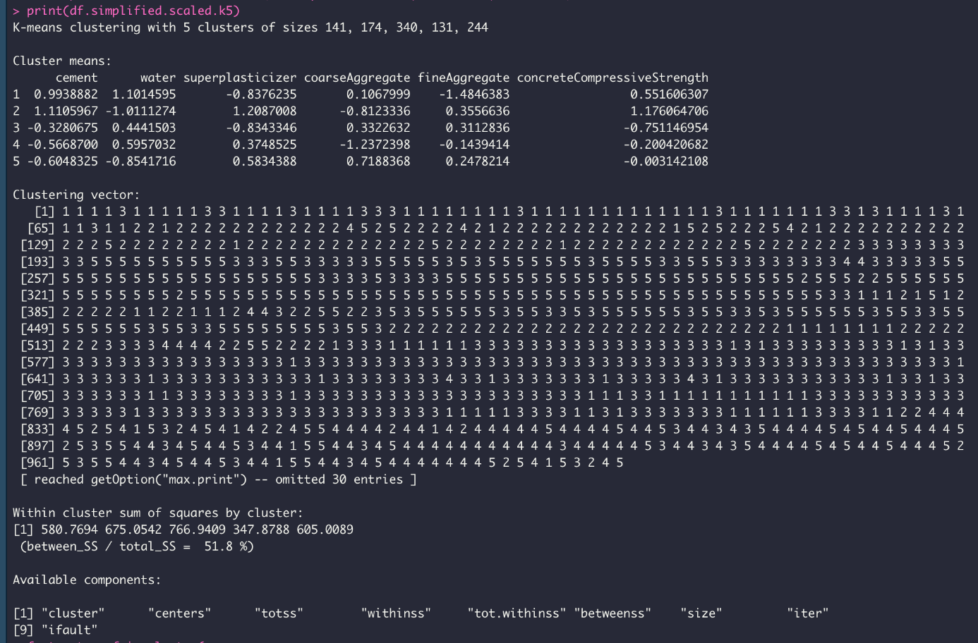

between_ss/total_ss has improved by about 5% to 51,8%.

The visualization of clusters:

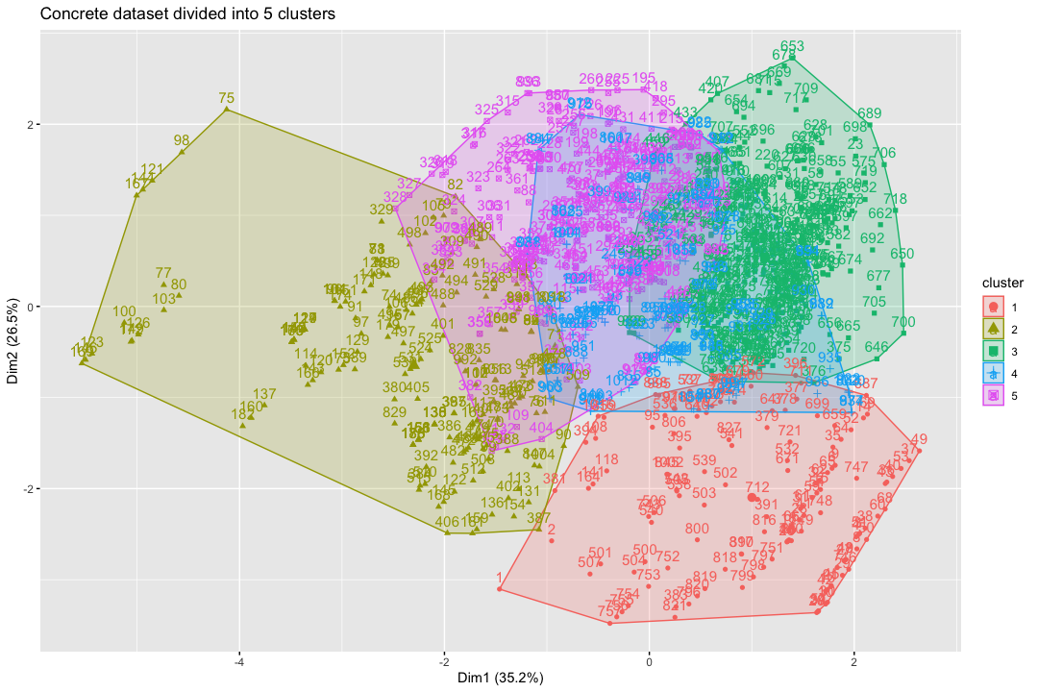

Again, purple and blue clusters are significantly overlapping with each other and with other clusters.

With k = 6:

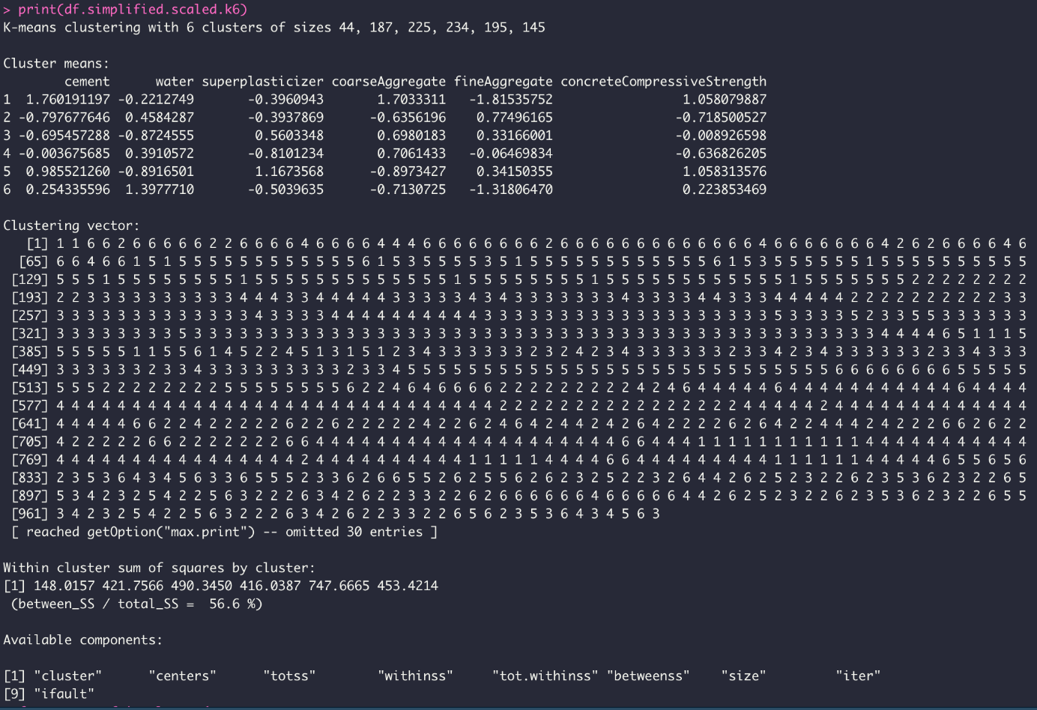

between_ss/total_ss has improved by about 5% to 56,6%.

The visualization of clusters:

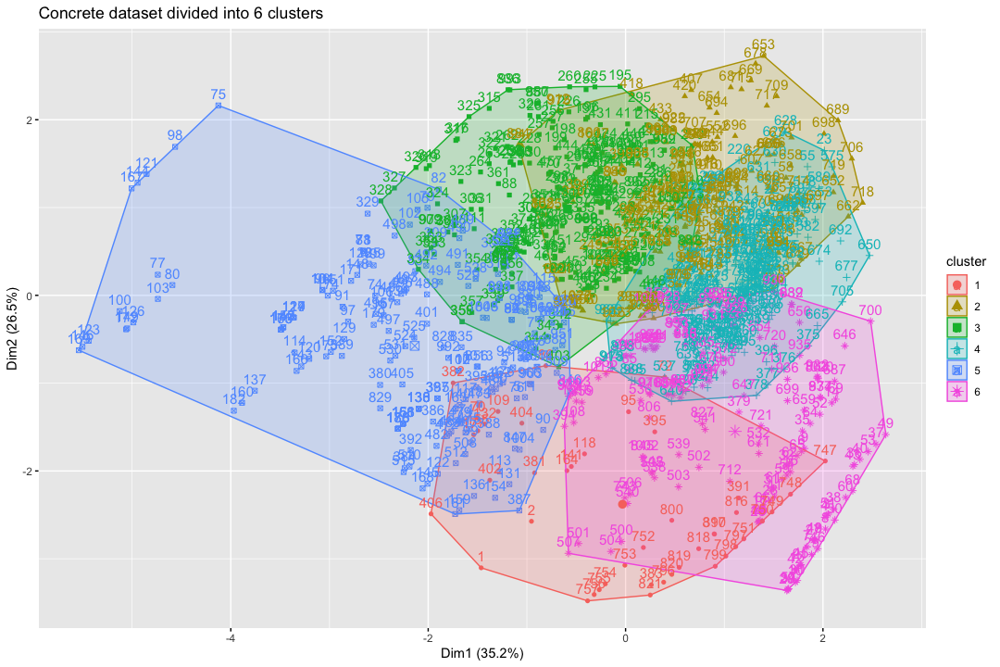

Here we can also observe a lot of overlapping areas between clusters.

The same K-means analysis have been conducted with z score scaled data set as well. The results are very similar since the data set itself is the same. In order to keep the report file short, we decided not to include all screenshots of that, since the results are very similar to above presented results. The code is included in script file, as well result screenshots can be found in full resolution in img folder of the report.

The best number of clusters is obtained using fviz_nbclust() function from factoextra package:

Min-max normalized: Z-score normalized:

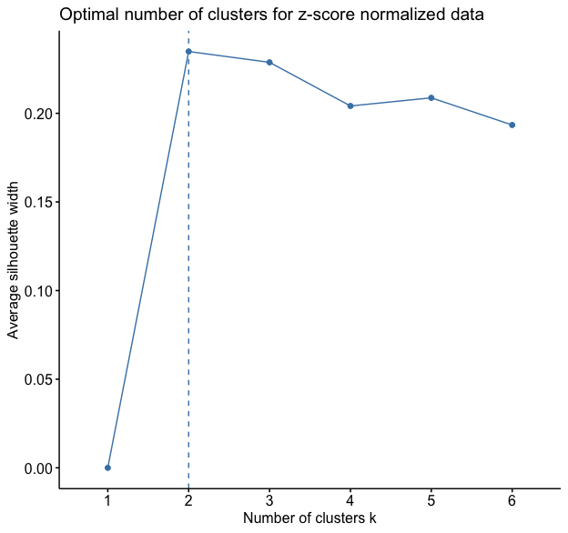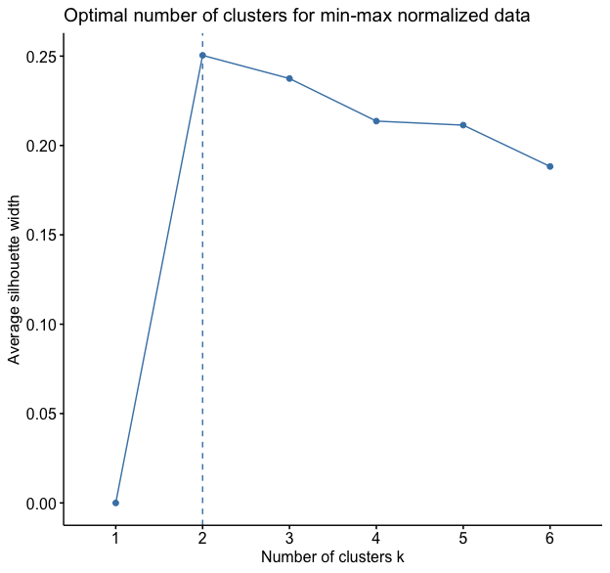

As can be seen the optimal number of clusters in both cases is two clusters, and as for the graphics itself, both are very similar to each other.

Now let’s analyze cluster centroids for optimal number of clusters (k=2):



To analyze these numbers we need to look at the largest number in each column. Indicates that is most important cluster for that attribute. In case of min-max normalized data, the most important cluster for:

cement – 2, water – 1, superplasticizer - 2, coarseAggregate - 1, fineAggregate - 1, concreteCompressiveStrength - 2

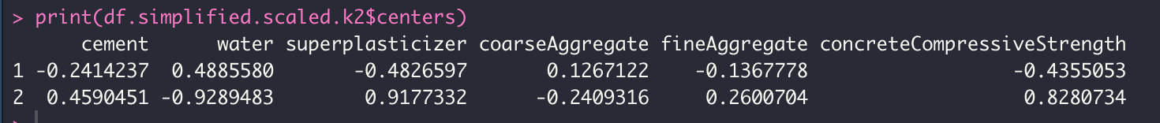

In case of z-scored normalized data we can have negative values as well, since z-score allows negative values, and the most important cluster for:

cement – 2, water – 1, superplasticizer - 2, coarseAggregate - 1, fineAggregate - 2, concreteCompressiveStrength - 2

Comparing two normalization techniques the only difference is in fineAggregate, all other are the same for both techniques.

**K-Nearest Neighbour**

**70/30 Ratio:**

After dividing our data to train set and test set in the given ratio, KNN classification method is used with the following code where we first get kmeans of train set, then apply knn to test set and then comparing results with cross table, and finally computing accuracy.

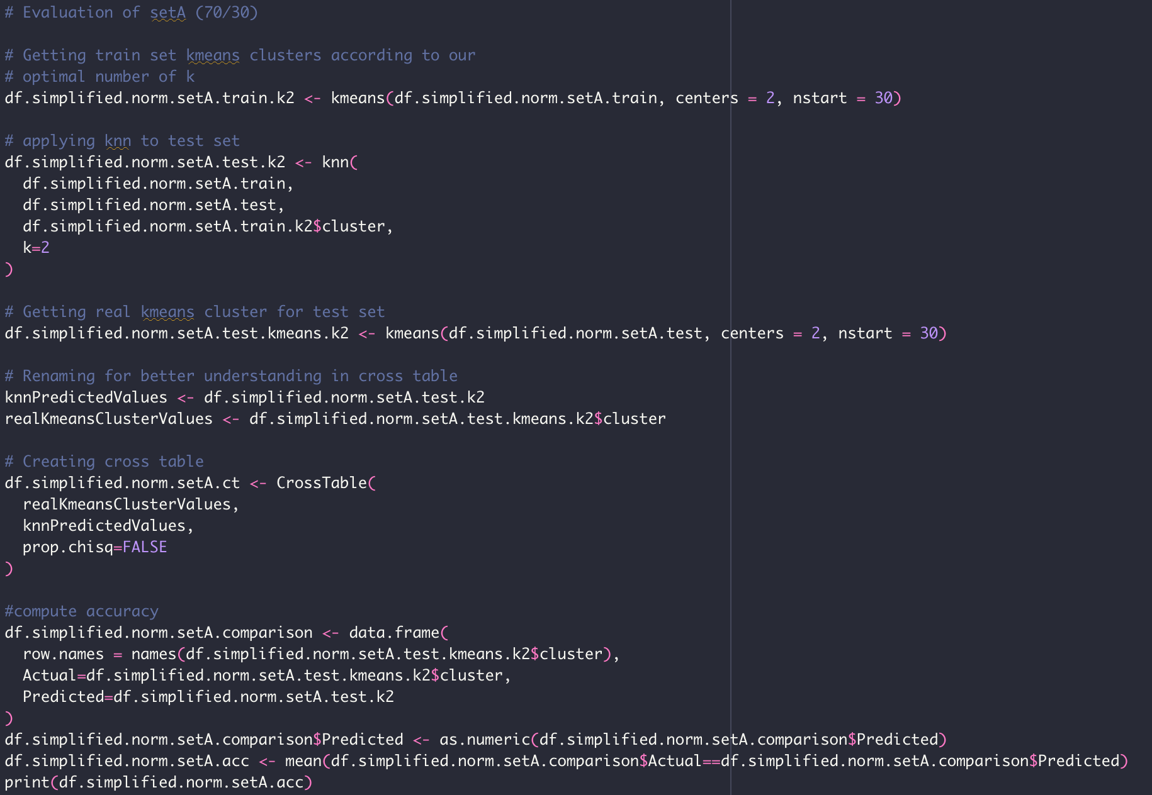

We get the following cross table:

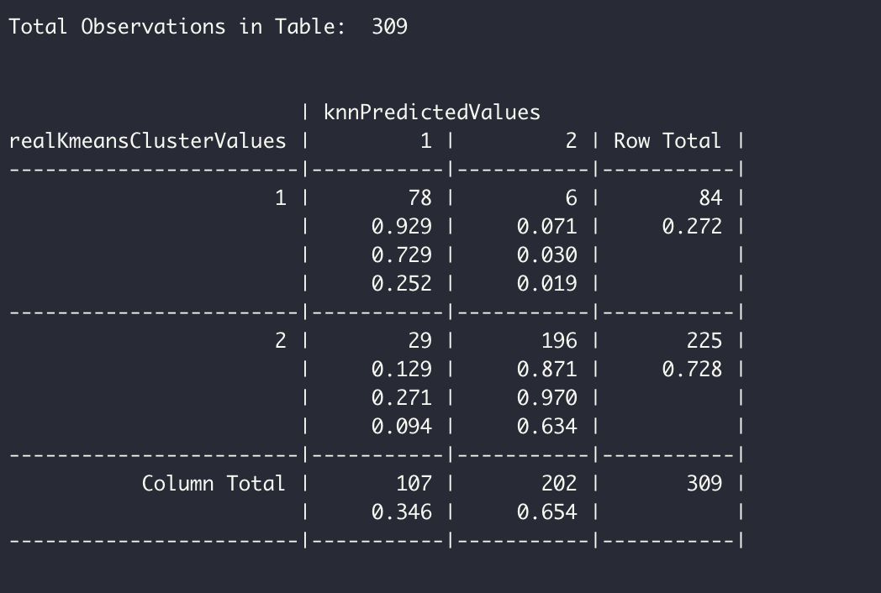

We can calculate the accuracy:

(78 + 196)/309 = 89%

**60/40 Ratio:**

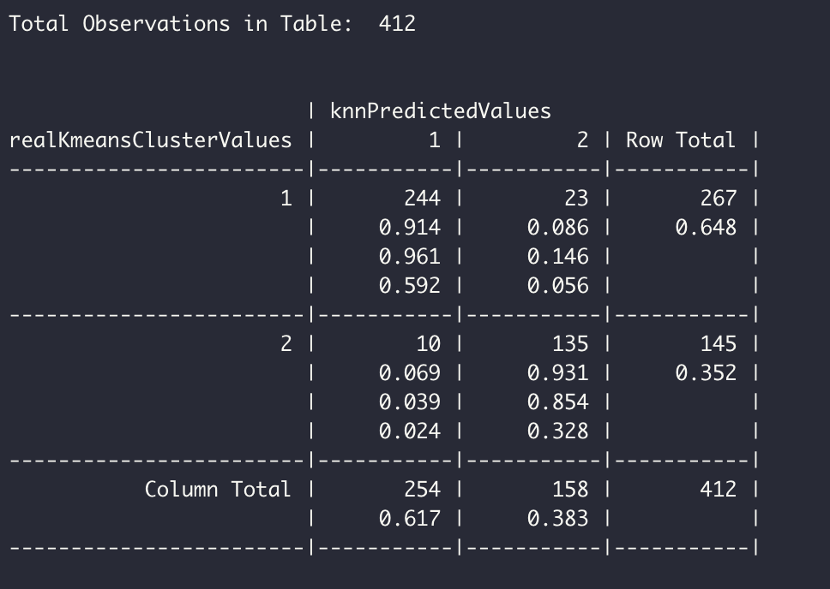

We can calculate the accuracy:

(244 + 135)/412 = 92%

**50/50 Ratio:**

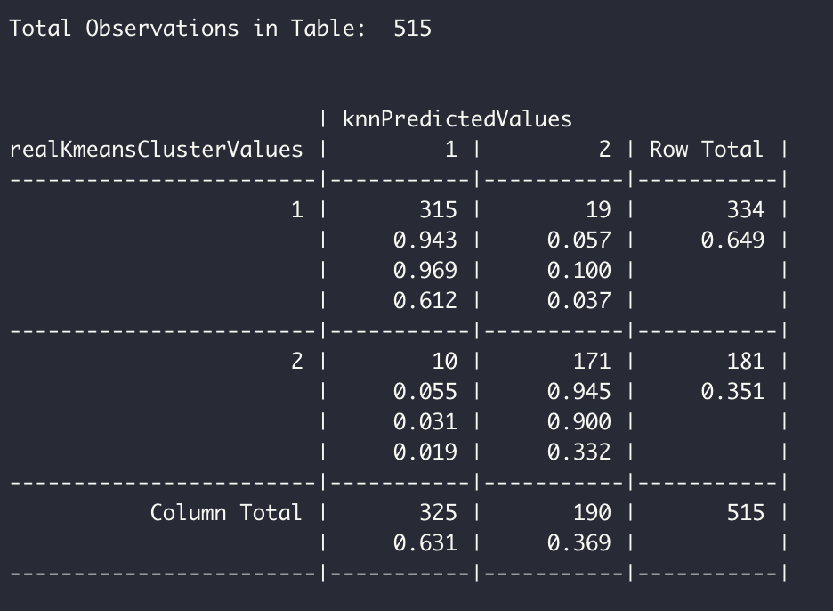

We can calculate the accuracy:

(315 + 171)/515 = 94%

|  |  |  |  |
| --- | --- | --- | --- |
|  | 70/30 | 60/40 | 50/50 |
| Accuracy | 89% | 92% | 94% |

As can be seen, predictions are pretty good. It is an effect of removing the columns that are not so correlated and cleaning data properly.

# Part 4

First of all, we specify values of Strength based on Concrete Compressive Strength. We used for that quantile() function. In Binomial Logistic Regression, values that fit to the first interval of the quartile got the value of 0 (which is associated with “low”) and 1 (= “high”) to the values of the second interval. For the Multinomial Logistic Regression values got the values depending on which interval they fit – 1, 2, 3 which are associated with “low”, “mid”, “high” respectively:

Binomial train data:

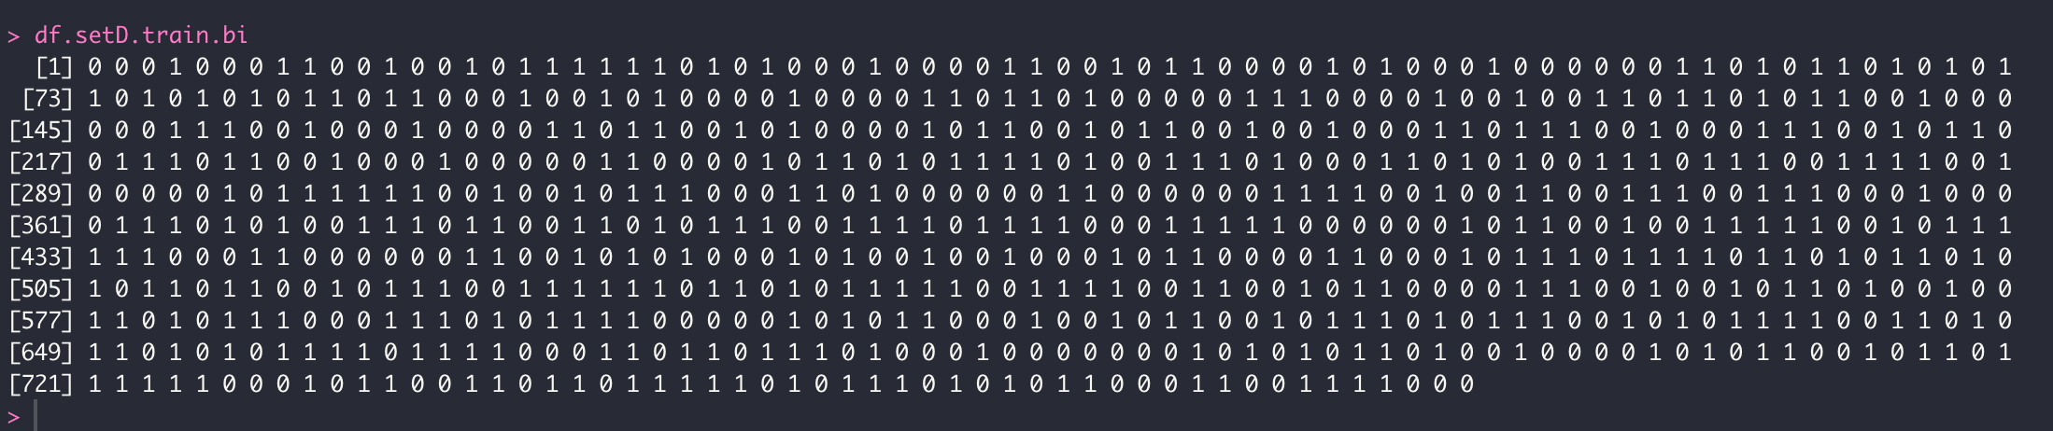

Multinomial train data:

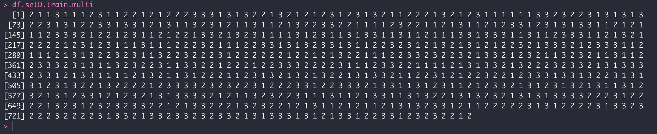

To apply Binomial Logistic Regression, we used glm() function and fitted data into it, here is summary of it:

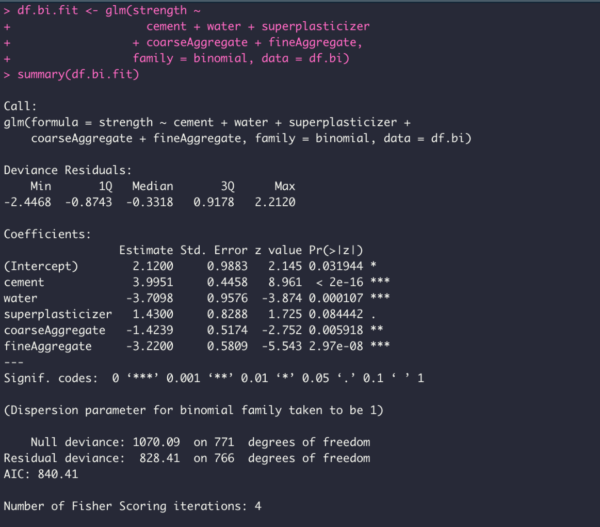

Here are accuracy, Confusion Matrix and Statistics of binomial logistic regression:

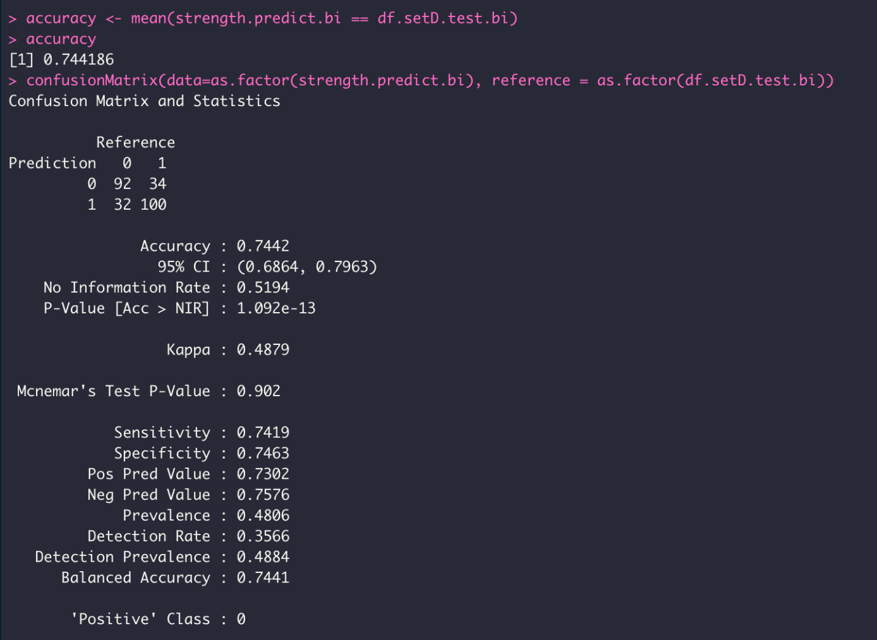

If we take “high” / 1 as positive, and “low” / 0 as negative:

True Positive: 100

False Positive: 32

True Negative: 92

False Negative: 34

When applying Multinomial Logistic Regression, we used multinom() function:

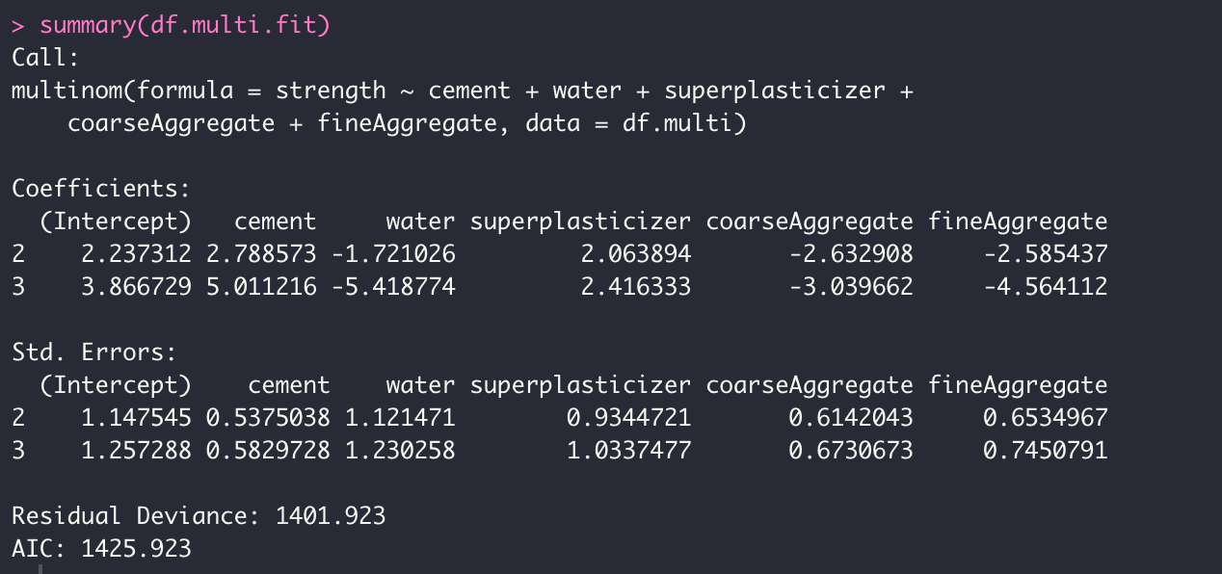

Here are accuracy, Confusion Matrix and Statistics of multinomial logistic regression:

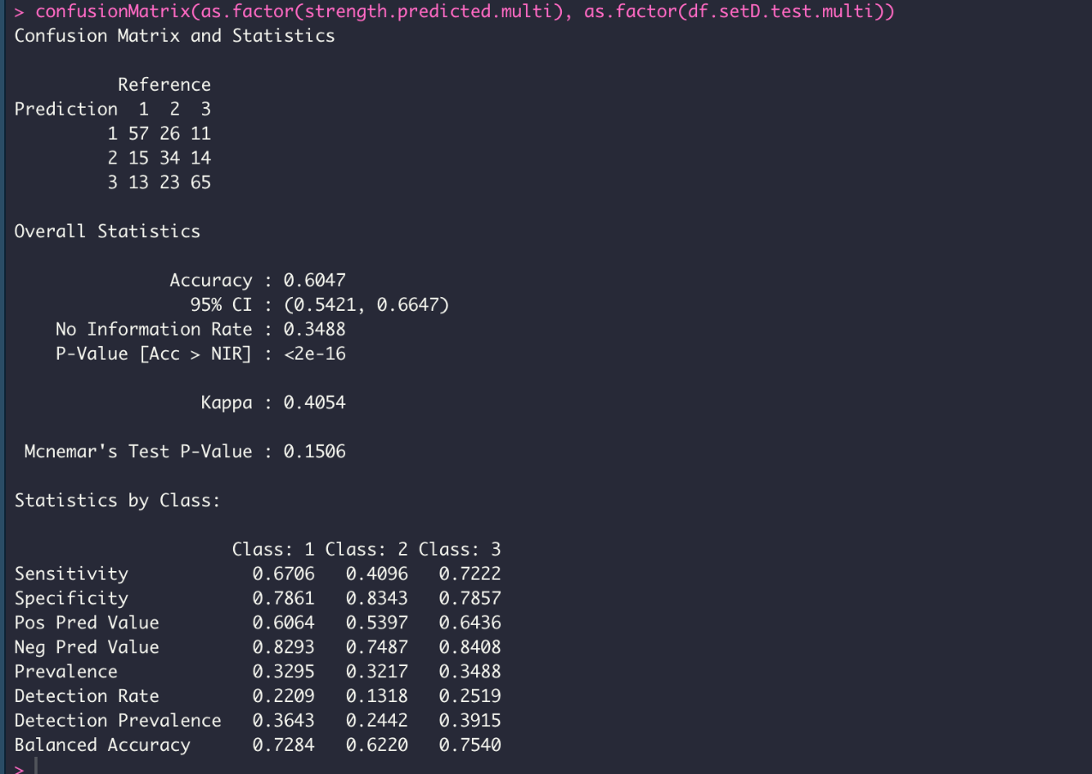

Next, we compared these results with our results that we got via KMeans algorithm with k = 3. Below, you can find the cross-tabulation of the results

As we can see there is: $\frac{(88+35+52)}{258}=67.8\%$ similarity

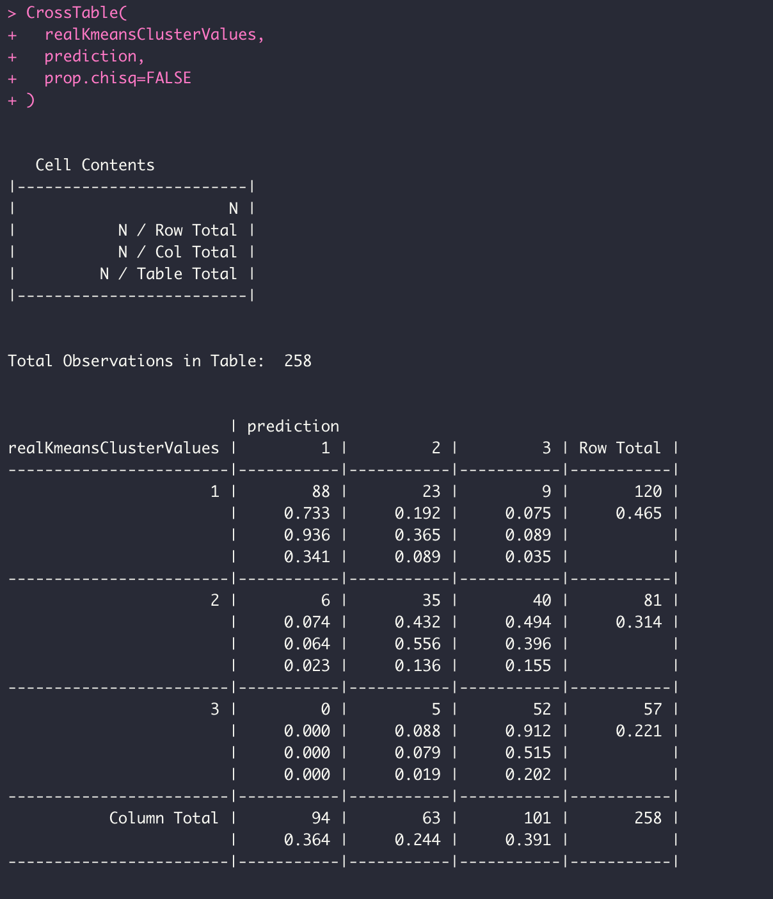

Our next step was trying multinomial logistic regression with different set of attributes. We decided to remove Coarse Aggregate as according to our correlation matrix that we plotted in Part 2, it had the least correlation with other attributes from the remained ones. Here is the summary:

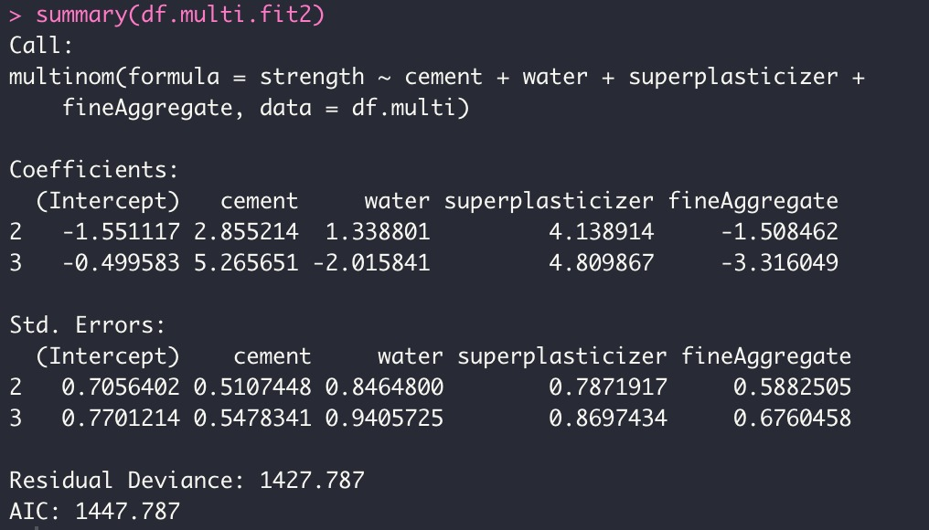

You can find below the Confusion Matrix. As we can see that accuracy decreased this time, so the results were quite good for the first time when we used Multinomial Logistic Regression.

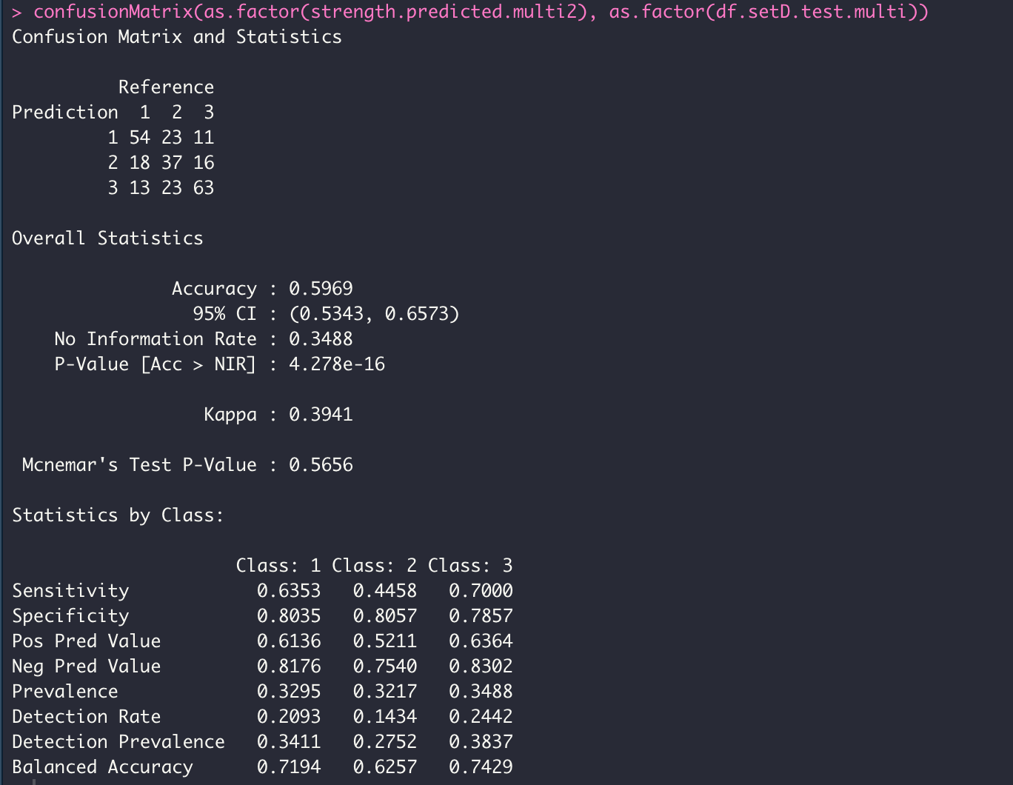

We also compared new results with our results from K-means algorithm (k=3). This time similarity was slightly less: $\frac{83+36+50}{258}=65.5\%$

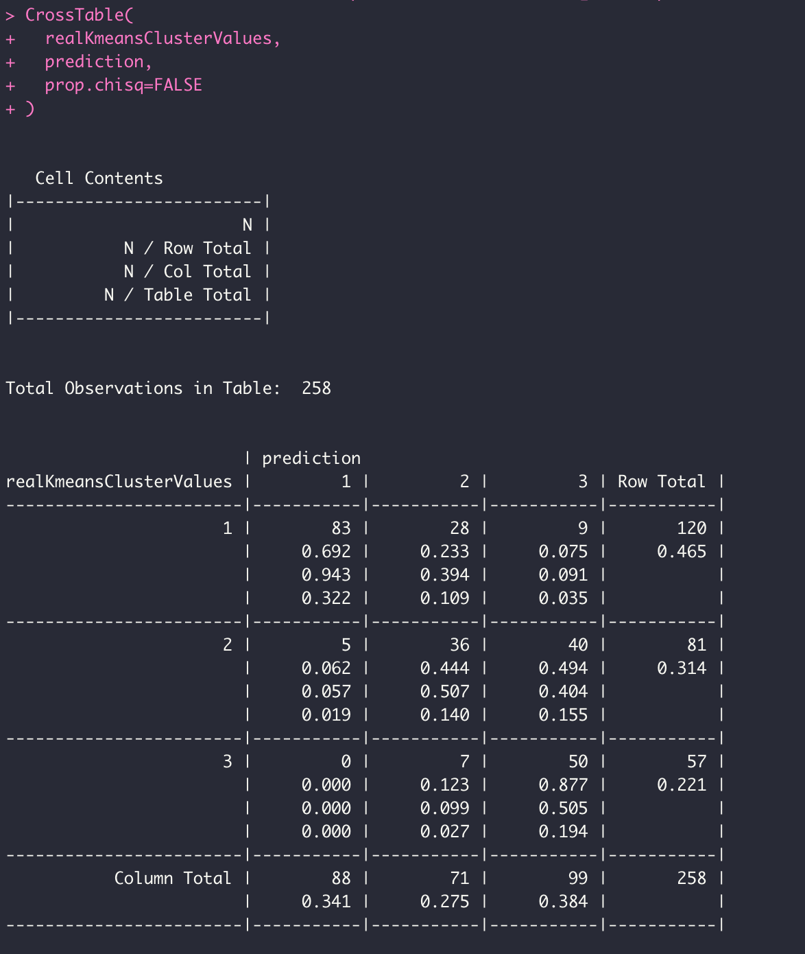

# Discussion

We found this project very helpful since it helped us to realize a few concepts and to transfer our theoretical knowledge into practical knowledge. Firstly, we learned the importance of plotting data to see the relationships between the attributes of the data which we did in the first part of our project. With the help of built-in functions and external package functions we could see the correlations of attributes in our data set, which helped us in the phases of our analysis.

Second important achievement was getting acquainted with Supervised and Unsupervised learning algorithms. In Part 3 we learned about clustering technique which is an unsupervised algorithm. We learned how to divide the given dataset into the clusters, and we also managed to learn how to find the most optimal number of clusters. We also learned about classification with K-Nearest Neighbor which is supervised algorithm. We implemented these two techniques in part 3, therefore we learned the ways of implementation of these techniques in R.

Lastly, we also learned about Linear and Logistic Regressions: Linear Regression while examining the tutorial posted on Blackboard and Logistic Regression during the Part 4 of this assignment. We learned about two ways to predict the values after training on the train dataset via Binomial and Multinomial Logistic Regressions.

To sum up, during this project we have learned several different techniques that are being used in data analysis and applied it in practice.